Logan Murray

CSC 373

Lytinen

Homework Assignment 1

Laptop in the $1,000 – 1,200 price range:

**MSI GP Series GP72MX Leopard-1214-🡪 $1,187 before tax**

Specs:

120 Hz refresh rate screen

Intel Core i7 7th Gen 7700HQ (2.80GHz)

NVIDIA GeForce GTX 1050—>4 GB

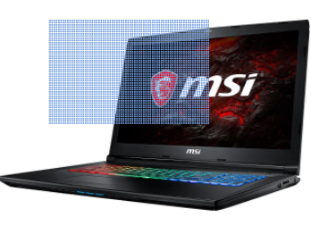16 GB RAM memory

128 GB NVMe Solid State Drive

1 TB of HDD memory

64-bit

*Quad-core Processor

6 MB CPU L3 Cache

Windows 10

**Most Important Factor:**

I like to game a lot and a laptop that can handle high end games that are really graphics heavy is important to me. So the latest in Video Cards like the 1050 is great, not to mention a screen with great resolution and refresh rate. 16 GB of RAM is pretty standard with high end gaming laptops which helps no doubt. And of course, games are getting bigger in size so a large hard drive comes in handy in the long run.